

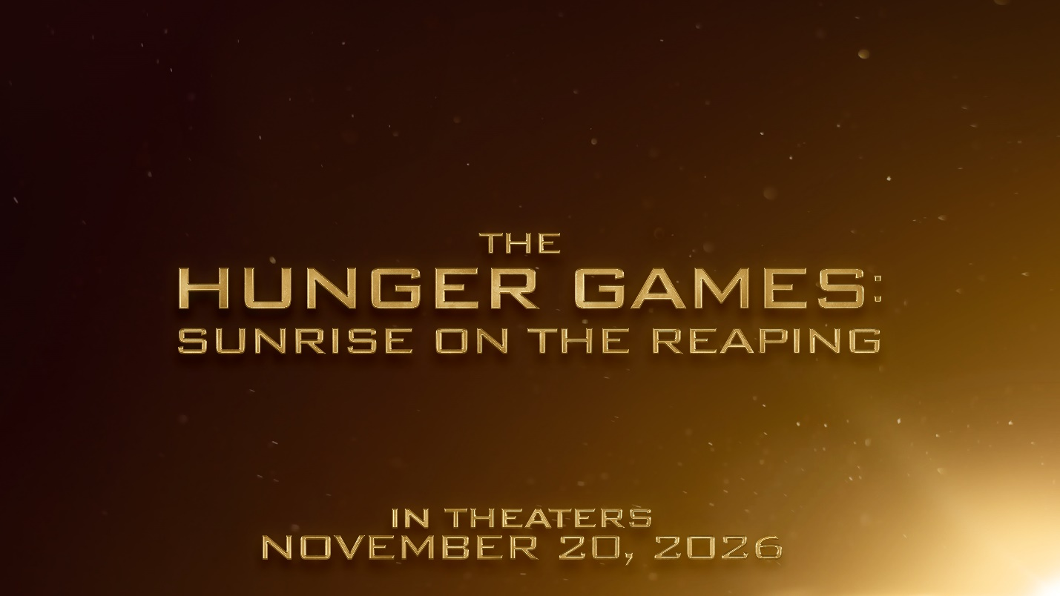

LIONSGATE TO ADAPT SUZANNE COLLINS’S
NEWLY ANNOUNCED HUNGER GAMES NOVEL
“SUNRISE ON THE REAPING”
INTO MAJOR MOTION PICTURE

$3.3 Billion Global Film Franchise Returns to Theaters November 20, 2026

SANTA MONICA, Calif., June 6, 2024 – Lionsgate (NYSE: LGF.A, LGF.B) will return to the world of Panem with the major motion picture adaptation of the next book in the franchise, Suzanne Collins’s highly anticipated Hunger Games novel Sunrise on the Reaping, it was announced today by Adam Fogelson, chair of the Lionsgate Motion Picture Group.

Franchise producer Nina Jacobson, alongside her producing partner Brad Simpson, will return to produce The Hunger Games: Sunrise on the Reaping under their Color Force banner. It will be the sixth outing for Color Force since bringing the franchise to Lionsgate in 2012. Francis Lawrence is in talks to direct the film; Lawrence has helmed four previous films in the Hunger Games franchise – every film since Catching Fire.

The film will be released in theaters in North America beginning on November 20, 2026.

The Hunger Games: Sunrise on the Reaping will revisit the world of Panem 24 years before the events of The Hunger Games, starting on the morning of the reaping of the 50th Hunger Games, also known as the Second Quarter Quell. One of the most eagerly awaited publishing events of the year, Sunrise on the Reaping will be published by Scholastic simultaneously in print, digital, and audio formats in the US, Canada, the UK and Ireland, Australia, and New Zealand on March 18, 2025.

There are more than 100 million copies of all four books in The Hunger Games series in print and digital formats worldwide, and foreign publishing rights have been sold in 54 languages. Lionsgate has adapted these best-selling books into five feature films that have collectively grossed more than $3.3 billion at the worldwide box office and boasted star-studded casts including Academy Award® winner Jennifer Lawrence, Josh Hutcherson, Liam Hemsworth, Academy Award® nominee Woody Harrelson, Elizabeth Banks, Lenny Kravitz, Stanley Tucci, Donald Sutherland, Rachel Zegler, Tom Blyth, Viola Davis, Jason Schwartzman, and Peter Dinklage.

The world of The Hunger Games that Suzanne Collins created continues to grow around the globe as theme park attractions, experiences, and live events, including The World of the Hunger Games at the Motiongate Dubai theme park and a major stage production set to debut in London from Olivier Award-winning playwright Conor McPherson (“Girl from the North Country”) and directed by Matthew Dunster (“2:22—A Ghost Story,” “Hangmen,” “The Pillowman”).

“Suzanne Collins is a master storyteller and our creative north star,” said Fogelson. “We couldn’t be more fortunate than to be guided and trusted by a collaborator whose talent and imagination are so consistently brilliant. We know Hunger Games fans worldwide will be spellbound by where Suzanne has focused this next extraordinary story. The Second Quarter Quell is legendary and looms large over the history of the Games, even into the time of Katniss Everdeen a quarter-century later. Like fans around the globe, we are eagerly anticipating this exciting return to Panem.”

“From the beginning, Lionsgate has been a wonderful home and partner for the Hunger Games franchise, and I’m very excited to be collaborating with Adam and the team as we bring this next story to theaters in 2026,” said Suzanne Collins.

Meredith Wieck and Scott O’Brien will oversee the production on behalf of the studio. Patricia Laucella and Phil Strina oversaw the rights for the book for Lionsgate. Collins was represented by Jason Dravis from The Dravis Agency and Diane Golden and Sarah Lerner from the law firm Katz Golden Lerner LLP.

ABOUT SUZANNE COLLINS AND THE HUNGER GAMES
Bestselling author Suzanne Collins first made her mark in children’s literature with the New York Times bestselling Underland Chronicles fantasy series for middle grade readers. She continued to explore the effects of war and violence on those coming of age with The Hunger Games series. The Hunger Games (2008) was an instant bestseller, appealing to both teen readers and adults. It was called “addictive” by Stephen King in Entertainment Weekly, and “brilliantly plotted and perfectly paced” by John Green in the New York Times Book Review. The book appeared on the New York Times bestseller list for more than 260 consecutive weeks (more than five consecutive years), and the total series has been on the series bestseller list for over 329 weeks to date. There are more than 100 million copies of all four books in the series—The Hunger Games, Catching Fire (2009), Mockingjay (2010), and The Ballad of Songbirds and Snakes (2020)—in print and digital formats worldwide. Foreign publishing rights for The Hunger Games Series have been sold in 54 languages to 52 territories to date. Lionsgate has successfully adapted each of these books into five feature films that collectively grossed more than $3.3 billion worldwide in theatrical ticket sales.

In 2010, Suzanne Collins was named to the TIME 100 list as well as the Entertainment Weekly Entertainers of the Year list; in 2011, Fast Company named her to their 100 Most Creative People in Business; and in 2016, she was presented the 2016 Authors Guild Award for Distinguished Service to the Literary Community for exemplifying the unique power of young people’s literature to change lives and to create lifelong book lovers. It was the first time the Guild presented its annual award to a YA author. The Atlantic called Hunger Games heroine Katniss Everdeen “the most important female character in recent pop culture history,” and TIME magazine named Katniss to its list of “The 100 Most influential People Who Never Lived.” On The Hunger Games trilogy, The New York Times Book Review wrote, “At its best the trilogy channels the political passion of 1984, the memorable violence of A Clockwork Orange, the imaginative ambience of The Chronicles of Narnia and the detailed inventiveness of Harry Potter.” The Ballad of Songbirds and Snakes was published in May 2020 and debuted at #1 on the New York Times, USA Today, Wall Street Journal, and Publishers Weekly bestseller lists. The book also was the top selling book in any category for the first half of 2020. On October 1, 2024, Scholastic will publish The Hunger Games Illustrated Edition, a deluxe illustrated edition of Suzanne Collins’ worldwide bestseller The Hunger Games, featuring more than thirty black-and-white illustrations by internationally acclaimed artist Nico Delort. For more information about The Hunger Games series, visit:
http://mediaroom.scholastic.com/hungergames.

Follow The Hunger Games online on these platforms:

https://www.facebook.com/TheHungerGamesMovie
https://www.instagram.com/thehungergames/
https://x.com/TheHungerGames
https://www.tiktok.com/@hungergamesofficial
https://www.youtube.com/@TheHungerGamesMovies

Lionsgate Socials:
https://www.instagram.com/lionsgate/
https://www.facebook.com/lionsgate/
https://www.tiktok.com/@lionsgate
https://www.youtube.com/user/LionsgateLIVE
https://x.com/lionsgate/

ABOUT LIONSGATE
Lionsgate (NYSE: LGF.A, LGF.B) encompasses world-class motion picture and television studio operations and the STARZ premium global subscription platform, bringing a unique and varied portfolio of entertainment to consumers around the world. The Company’s film, television, subscription and location-based entertainment businesses are backed by a more than 20,000-title library and a valuable collection of iconic film and television franchises. A digital age company driven by its entrepreneurial culture and commitment to innovation, the Lionsgate brand is synonymous with bold, original, relatable entertainment for audiences worldwide.

ABOUT LIONSGATE STUDIOS
Lionsgate Studios (NASDAQ: LION) is one of the world's leading standalone, pure play, publicly-traded content companies. It brings together diversified motion picture and television production and distribution businesses, a world-class portfolio of valuable brands and franchises, a talent management and production powerhouse and a more than 20,000-title film and television library, all driven by Lionsgate's bold and entrepreneurial culture.

ABOUT COLOR FORCE
Color Force is a leading independent film and television production company that develops and produces some of the most acclaimed and successful films and television series today. Led by producer and film executive Nina Jacobson, who founded the company in 2007, and Brad Simpson, who joined Jacobson in 2012, some of Color Force’s most successful film and television projects include worldwide phenomenon The Hunger Games franchise, as well as Crazy Rich Asians, The Diary of a Wimpy Kid franchise, and for television, FX’s critically acclaimed “Pose” and “American Crime Story” anthology series, including Emmy® and Golden Globes® Awards winning “The People v. O.J. Simpson: American Crime Story.”

Up next for Color Force is limited series the upcoming Aaron Hernandez story for the “American Sports Story” anthology series and limited series “Say Nothing,” adapted from Patrick Radden Keefe’s book, “Say Nothing: A True Story Of Murder And Memory,” both for FX. Color Force’s most recent releases include FX’s “Clipped,” about the downfall of LA Clippers’ owner Donald Sterling; one of the biggest holiday tentpoles of 2023, Lionsgate’s prequel to The Hunger Games franchise, The Ballad of Songbirds & Snakes; as well as FX’s “Impeachment: American Crime Story” and “Y: The Last Man.”

The production company’s film and television slate is demonstrative of Jacobson and Simpson’s driving aspiration to tell stories that challenge assumptions and create empathy from shared experiences. As a result, the pair have personally won two Emmy® Awards, two Golden Globes, three TCA Awards, three Critics Choice Awards, two PGA Awards, three AFI Awards, two GLAAD Awards, as well as a BAFTA Award, an NAACP Award and a Peabody.

FOR MORE INFORMATION:
Steve Elzer
Elzer & Associates
steve@elzerassociates.com
(213) 392-4660

